In January of 2016, SaskInteractive worked with Derek Murray Consulting & Associates to develop a comprehensive industry profile. This was done to gain a comprehensive view of Interactive Digital Media (IDM) in Saskatchewan and across Canada so that SaskInteractive could see the strengths and gaps in Saskatchewan’s IDM industry and where it fits in assisting the industry. Outlined below is the condensed version of that survey. Full version is available by contacting memberservices@saskinteractive.com.

Saskatchewan Interactive Media Association Industry Profile and Inter-Jurisdictional Research Project-Summarized

What is Interactive Digital Media and what does the industry do?
Canadian Interactive Alliance defines IDM as “(d)igital content and environments with which users can actively participate or which facilitates collaborative participation among multiple users for the purposes of entertainment, information or education, and is commonly delivered via the Internet, mobile networks, gaming consoles or media storage devices. The two essential sub-sectors of the interactive digital media industry include the entities creating the end-user experience (creators) and those designing the applications allowing for the creation or distribution of the content and environments to the user (enablers).” (CIAIC, 2009). Although IDM is an ever expanding industry, a comprehensive list of industry activities was compiled by Nordicity to include the following:
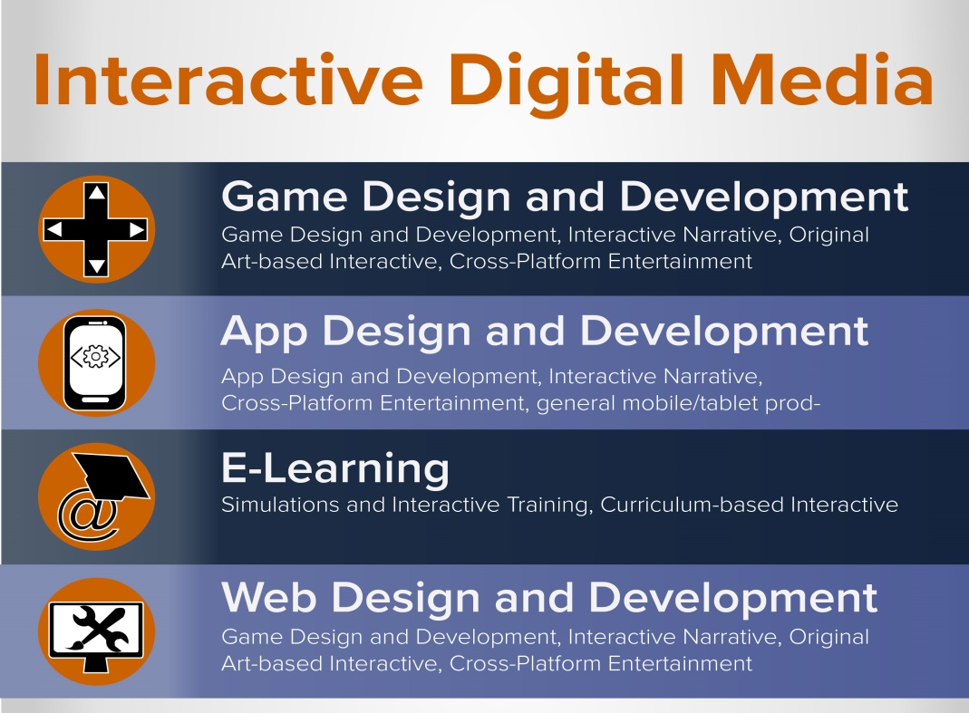

What does IDM in Saskatchewan look like?

In many ways, Saskatchewan is a supportive environment for the IDM industry. With government initiatives such as the Saskatchewan Innovation Agenda which supports the IDM community in their research towards enhancing Saskatchewan’s three main economic areas (agriculture, oil and gas, and mining). There is also the newly formed ICT (Information and Communications Technology) Stakeholder Steering and Advisory Committee. Unlike the Innovation Agenda, this committee will focus on the ICT sector and how it can be supported and grown in Saskatchewan. This is important for the IDM industry as they are a major component of the ICT industry.

Saskatchewan is also seeing a positive growth in business and employment. As seen in the graphic below, Saskatchewan has seen a 39% increase overall between 2011 and 2014 which comes out to an 11.6% annual increase.
2011 Nordicity Employment Versus 2014 NAICS Employment
 | 2011 (Nordicity) | 2014 (NAICS)
Prairies | 1,869 | 3,853.8
- Manitoba | 340.5 | 449.8
- Alberta | 1,222.3 | 3,063.4
- Saskatchewan | 306.3 | 340.6
Ontario | 8,277 | 14,971.3
BC | 7,209 | 5,803.9
Quebec | 4,806 | 11,106.8
Atlantic Canada | 3,738 | 793.2
Other | 801 | 589.7
TOTAL | 26,700.0 | 37,118.8

And although Saskatchewan is trending behind most of the rest of Canada as far as incidence of IDM employment relative to the overall workforce (only 0.06%), the province has a strong IDM industry that continues to grow.

Stepping back from the national scale and focusing provincially, it is clear that IDM industry is flourishing. The chart below shows that Saskatchewan has seen 19% growth over the last year. And this number is expected to rise; 39% of people surveyed for this report projected to hire in the next three months.

Saskatchewan IDM Employment – Survey Results
2014 (November) Employment | 2015 (November) Employment | 2016 (February) Employment
365.3 | 433.1 | 473.3
 | 18.56% | 9.28%

This type of explosive growth is to be expected considering that globally this is one of the fastest growing industries. Data tracking from Sinapore shows employment in IDM grew at a Compound Annual Growth Rate (CAGR) of 17.5% between 2008-2012. Closer to home, a survey in Manitoba in 2012 projected a 16.4% growth rate in the IDM sector.
Growth Rate in Saskatchewan

However, when a comparison is made between the growth rate of IDM in Saskatchewan to other industries within the province, there is no doubt that IDM is exploding. These initial figures are both impressive and important for the IDM community at large in Saskatchewan as they provide a baseline for demonstrating the future impact that IDM can have on Saskatchewan’s economy overall.

What are the key support mechanisms for IDM?
There are four pillars that lead to a healthy environment for fostering IDM growth. These pillars were a result of the interjurisdictional research that explored how each region across the country supported and fostered growth in the IDM sector. Each section is explored in depth below.

Commercialization
and Incubation

Suite of Competitive Incentives
Interactive Digital Media Sector
IDM Business
Infrastructure
Active Industry
Association

IDM Business

IDM is an area that requires skilled people from a number of areas. The primary skills required are business admin (21%), creative development (38%), and technical (41%). There are a number of other factors that go into IDM business and as illustrated below, there are a number of strengths and gaps in Saskatchewan.

GAPS
STRENGTHS

Training and Labour

Saskatchewan has a highly developed training system for the IDM field through education offered by institutions such as Saskatchewan Polytechnic, universities, Saskatchewan Indian Institute of Technology, and other professional development courses.

Despite the developed training infrastructure, 46% of people surveyed for this report indicated sourcing skilled labour in the IDM industry in Saskatchewan is a challenge. Some people felt that it was important for potential employees to have basics and that the specific skill could be taught and that continued focus on training was key.

Digital Infrastructure

Saskatchewan is in a good position as far as digital infrastructure is concerned and 93% of people surveyed indicated that it was an asset, especially in areas serviced by fibre. Having Sasktel, a publically owned telco, means that there is a high probability that Sasktel would be willing to participate in growing the IDM sector.

Research & Development (R&D)

In Saskatchewan, the presence of three research facilities that together cover a much of the IDM sector. These facilities are a major benefit to IDM in Saskatchewan currently and will to be an integral part of the growth and success of the sector within the province.

Procurement and Vendor Relations

During the survey, procurement was referenced as a challenge specifically when it came to Crown Corporation and government procurement. From the comments, it was gleaned that the industry felt that there was room for improvement when it came to giving Saskatchewan companies the opportunity to bid on contracts and the conversations between Saskatchewan companies and procurement units. Coincidentally, the Government of Saskatchewan is using a program called Priority Saskatchewan to review the current procurement processes.

Financing

Unfortunately, financing for the IDM industry in Saskatchewan is an issue. Many surveyed were neutral on traditional bank financing as it was not an option they had pursued. Other forms of financing, such as venture or angel investors are lacking for the IDM industry. Saskatchewan has two venture capital firms (Golden Opportunities Fund and SaskWorks) but neither specifically target IDM. There is also Saskatchewan Capital Network for angel investors which is active but they face challenges due to the lack of a tax credit for angel investors.

Tax Regime and Operating Environment

Saskatchewan is highly competitive when it comes to corporate tax rates with rates ranging from 2% on the lower end to 12% on the higher end. The province is also below average in both Saskatoon and Regina for municipal commercial property tax rates as seen in the below graph.

2014 Comparative Municipal Commercial Property Tax Rates

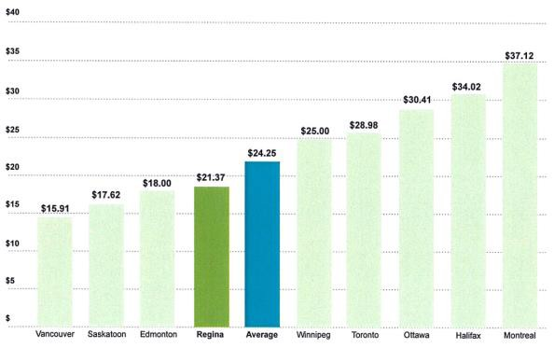
Source: 2014 Property Tax R ate Analysis , Real Property Association of Canada

Business Start-Up Support

Saskatchewan has two start-up support networks: Square One and BizPal. Both organizations work with new businesses to navigate through regulations with Square One also helping with market research and BizPal with permitting and licensing. In addition, Saskatchewan has been reducing red tape when it comes to the regulatory environment making it easier for businesses in Saskatchewan.

Commercialization and Incubation

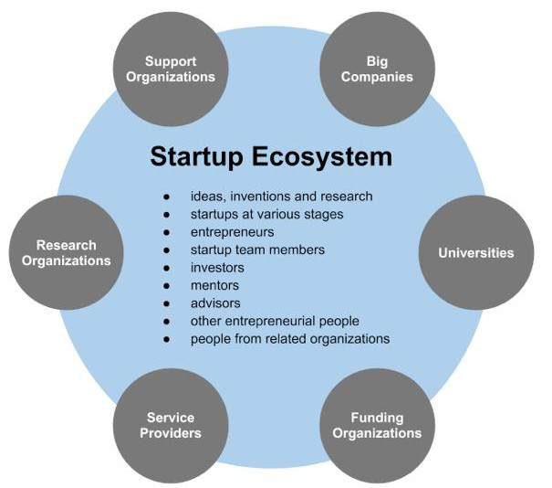
startupcommons.org
Creating and supporting a health start-up environment requires incubators, technology transfer, and research and development funds as pictured on the left. When these items are put in place strategically and comprehensively, the impact on the IDM industry is great. An example of this is in Manitoba with the Innovation Strategy which supports the broader innovation sector and their efforts have seen an additional 5.8 million in funding from the federal government. Currently, Saskatchewan in the process of developing an ICT strategy that would attract additional funding for the IDM sector.

And although Saskatchewan has been late coming to the table on this idea, there have been a number of start-up support and incubators open in the last five years. These include groups such as TwoTwenty, Co-work Regina, Ideas Inc, WallStreet Common, Startup Saskatoon, and The Launch. These groups offer everything from space to networking opportunities to business coaching.

Competitive Incentives

Interactive media is one of the fastest growing industries with a CAGR of 10.68% from 2015-2019 as per the Global Interactive Media Marketing Market. With such a fast growing industry, there needs to be support financially to help businesses start and then grow. Nationally, there are five programs:

In Saskatchewan, the financial support is lags behind many other jurisdictions. With a lack of an active technology industry association, there is very little analysis to show how the industry can be supported. Recently the Saskatchewan government convened a committee called Saskatchewan ICT Strategy to gather more information on how to grow the IDM sector. And although that will provide valuable information for the future, the current situation shows Saskatchewan lacking support in comparison to other provinces.

Provincial Incentive Environment for Interactive Media
 | BC | AB | SK | MB | ON | QC | NB | NS | PE | NL
Loans and Loan Guarantees |  |  |  |  |  | X
Digital Media Tax Incentives | X |  |  | X | X | X | X | X | X | X
Non-Refundable R&D Tax Incentives (SR&ED) |  |  | X | X
Refundable R&D Tax Incentives (SR&ED) | X | X |  |  | X | X | X | X |  | X
Investor Tax Incentives | X | X |  | X |  |  | X |  |  | X
Grants and Contributions | X | X | X * | X | X |  | X | X
Venture Capital Program | X | X |  |  | X | X
*Creative Saskatchewan

Currently Saskatchewan only supports two incentives: non-refundable R&D and grants/contributions specifically from Creative Saskatchewan. The R&D tax credits have both pros and cons for the IDM sector. On the positive, recent changes to the program in Saskatchewan is much less competitive but on the flip side, those tax credits are now non-refundable meaning that the credits are not accessible if the company is not paying tax. This is a particularly prevalent situation among start-up companies who don’t necessarily see profits in the first years.
Creative Saskatchewan offers grants and contributions to the IDM industry through two streams: screen based media and market development/research. For screen-based media, there is the Media Production Grant which goes towards production and a Media Content Development Grant that assists in helping fund projects that assist in bringing productions closer to fruition. On the market development and research side, there is:
- Creative Saskatchewan SaskTel Equity Fund for television based projects
- Market & Export Development that supports established industries with “market interest by invitation”
- Research Grant for the creative industries in general

